
KIDZ KONNEKT
Kidz Konnekt
Eston Leisure Centre
Normanby Road
Middlesbrough
TS6 9AE
07824883335

KIDZ KONNEKT SAFEGUARDING/CHILD PROTECTION POLICY

SECTION 1 POLICY STATEMENT
Kidz Konnekt is firmly committed to the belief that all children and young people have a fundamental right to be protected from harm, and fully recognises its responsibility for safeguarding and child protection. The safety and protection of all children and young people that Kidz Konnekt supports is paramount and has priority over all other interests.
The purpose of this Safeguarding and Child Protection Policy is to ensure, always, the maximum protection from any kind of harm for all children, young people and vulnerable adults, involved in any way with Kidz Konnekt. For the purposes of this policy Kidz Konnekt has defined harm as:
- Abandonment – leaving a child alone and unattended in circumstances that are inappropriate for their age/level of ability.
- Emotional/Psychological abuse – persistent emotional ill treatment that has a severe adverse effect on the emotional development of a young person. It may involve conveying to them that they are not wanted, not loved, useless, worthless. It may involve inappropriate expectations (such as taking on the responsibilities of an adult within the family) being placed on the young person leaving them feeling frightened and unable to cope. It may also involve the exploitation or corruption of young people.
- Neglect – the persistent failure to meet the basic physical and physiological needs of a young person that results in the serious impairment of their health and development, including the failure to provide adequate food, clothing and shelter and failure to respond to basic emotional needs, such as being cared for when sick.
- Physical abuse – hitting, kicking, shaking, slapping, throwing, burning, scalding, poisoning, drowning, suffocating or any other action intended to cause physical harm or ill-health to a young person.
- Financial or Material abuse – Theft or exploitation in financial matters or transactions, and the misuse or misappropriation of possessions or benefits.
- Discriminatory abuse – This may involve racist, sexist and religious abuse; abuse that is based on a person’s disability, size, gender, age or marital status.
- Domestic abuse - This includes psychological, physical, sexual, financial, emotional abuse; so called ‘honour’ based violence.
- Modern slavery –This encompasses slavery, human trafficking, forced labour and domestic servitude.
- Self-neglect – This covers a wide range of behaviours including neglecting to care for one’s personal hygiene, health or surroundings, and includes behaviours such as hoarding.
- Female Genital Mutilation (FGM) – This includes procedures that intentionally alter or injure the female genital organs for non-medical reasons.
- Sexual abuse or sexual exploitation – forcing or enticing a young person to participate in sexual activities, whether or not the young person is aware of what is happening. It includes child prostitution, encouraging young people to watch or participate in the production of pornographic material and encouraging young people to behave in sexually inappropriate ways. Sexual acts include penetrative and non-penetrative acts such as touching or stroking.

The Sexual Offences Act 2003 defines ‘consent’ as ‘if he/she agrees by choice and has the capacity to make that choice’. The Act removes the element of consent for many sexual offences for:
- Children under 16 (including under 13)
- Children under 18 having sexual relations with a person in a position of trust (E.g. teachers, police officers; youth workers, foster carers)
- Children under 18 involved with family members over 18
- Persons with a mental disorder impeding choice or who are induced, threatened or deceived
- Persons with a mental disorder who have sexual relations with care workers
In relation to young people under the age of 13, consent is irrelevant. The law says, ‘a child under the age of 13 does not, under any circumstances, have the legal capacity to consent to any form of sexual activity’. The Police must be informed immediately of any sexual activity involving a child under 13.
- Peer abuse - Young people are vulnerable to abuse from their peers, particularly when they are away from home. Teenagers and younger children commit a significant proportion of sex offences. Any such abuse must be taken as seriously as abuse perpetrated by an adult and the same procedures must be followed.
- Exposure to drug/alcohol misuse - encouraging or permitting young people who are under the legal age to use alcohol and drugs in a way that is harmful to their health.
- Radicalisation - attempting to radicalise vulnerable children and young people to hold extreme views including views justifying political, religious, sexist or racist violence, or to steer them into a rigid and narrow ideology that is intolerant of diversity and leaves them vulnerable to future radicalisation.
This policy forms part of the Terms and Conditions of Employment and applies to all employees. Its purpose is to protect the personal safety of all children and young people using the facilities, resources and activities provided by Kidz Konnekt by actively promoting awareness, good practice and sound procedures.

Vulnerability of Children and Young People with Additional Needs

Children with additional needs, including those with physical disabilities, special educational needs, emotional and behavioural difficulties or mental health issues are particularly vulnerable and at greater risk of all forms of abuse, including abuse whilst being cared for in institutions. The presence of multiple disabilities increases the risk of both abuse and neglect. Children with disabilities have the same rights to protection as any other child. People caring for and working with children with additional needs need to be alert to the signs and symptoms of abuse.
Children with disabilities may be especially vulnerable to abuse for a number of reasons:
- An increased likelihood that the child is socially isolated
- A need for practical assistance in daily living, including intimate care
- Physical dependency with consequent reduction in ability to be able to resist or avoid abuse
- Communication or learning difficulties preventing disclosure or making disclosure more
- difficult
- Carers and staff lacking the ability to communicate adequately with the child
- The child being especially vulnerable to bullying, intimidation or abuse by their peers
- Some sex offenders may target disabled children in the belief that they are less likely to be
- detected
- Over-identification with the needs of parents/carers that can lead to a professional reluctance
- to make judgements about aspects of parenting
In addition to the universal indicators of abuse/neglect, the following abusive behaviours must be considered in relation to children/young people with disabilities:
- Force feeding
- Unjustified or excessive physical restraint
- Rough handling
- Behaviour modification techniques which include the deprivation of liquid, medication, food
- or clothing
- Misuse of medication, sedation, heavy tranquillisation
- Invasive procedures against the child’s will where the child is competent
- Failure to attend medical appointments and/or follow medically recommended treatment
- programmes where the child suffers harm as a result
- Ill-fitting equipment e.g. callipers, sleep boards which may cause injury or pain
- Misappropriation/misuse of a child’s finances
Safeguards for children with additional needs are essentially the same as for all other children. Particular attention should be paid to promoting a high level of awareness of the risks of harm and to high standards of practice. Concerns about the welfare of a child with a disability should be acted upon at an early stage in the same way as for any other child as detailed in the procedures.
Vulnerable Adults
As well as children and young people, the safeguarding procedures outlined below are also to be followed in the case of working with vulnerable adults. A vulnerable adult is:
- a person over the age of 18 who is or may be in need of community care services by reason of mental or other disability, age or illness
- a person who is, or may be, unable to take care of him or herself
- a person who is unable to protect him or herself against significant harm or exploitation

Kidz Konnekt holds a separate Safeguarding Adults Policy and Procedure

SECTION 2 POLICY PROCEDURES
Personnel/Recruitment
Kidz Konnekt practices robust recruitment procedures in checking the suitability of staff and volunteers to work with children and young people, this includes:
- All employees will complete an application form and will be interviewed.
- All employees are required to provide references, which are always verified.
- All employees are required to provide evidence of their identity and qualifications.
- All potential employees are expected to disclose any convictions, cautions, court orders or reprimands and warnings which may affect their suitability to work with children or young people.
- All employees have DBS checks at a level appropriate to their role. In the event of employment, any failure to disclose convictions will result in disciplinary action or dismissal.
- Staff will not have unsupervised contact with children or young people until their suitability has been checked.
- All new employees are required to sign up to the DBS online update service. Existing employees will be required to sign up when their DBS is next renewed. Sign up to the update service must be completed within 14 days of DBS check having been completed.
- Status checks through the update service will be completed for all employees.
- No person disqualified under the Childcare Act 2006 will be employed in Kidz Konnekt’ projects. All staff in these settings are required to declare (using the Disqualification Declaration Form) if they live in the same household as someone who is disqualified, and therefore, may be disqualified by association.
- All employees will receive Safeguarding and Child Protection Training as part of their induction and throughout their employment at a level and frequency suitable for their role (detailed in Kidz Konnekt’ Staff Training Overview).
- All Employees are provided free Core Level 3 Safeguarding Training as part of their training and it is mandatory that all staff repeat the training every 3yrs with 1 on-line refresher between each L3 core training.
- All Kidz Konnekt Trustees are DBS checked and hold relevant Safeguarding Training.

Responsibilities (Organisation)
- Kidz Konnekt will ensure a minimum of three senior members of staff are Designated Safeguarding Leads with responsibility for safeguarding and child protection and the implementation of this policy. It is the responsibility of the Designated Safeguarding Leads to take appropriate action following any expression of concern and to make, or support other members of staff to make, referrals to the appropriate agency.
- Karen McGarrity: Director (Trustee)
- Alan Lonsdale: Youth Development Manager
- Kerry Larkin: Senior Youth Worker (DSL)
- Joseph Whittingham: Senior Outdoor Education Officer

All employees will be made aware of the named Safeguarding Leads and how to contact them (Appendix One).
- Kidz Konnekt will ensure that all staff members receive training to update them on Child Protection and Safeguarding at a level and frequency suitable for their role.
- The Designated Safeguarding Leads will ensure that advice is sought from relevant child protection agencies when dealing with more complex issues.
- Kidz Konnekt will ensure that all employees receive regular monitoring and supervision in their work with children and young people.
- Kidz Konnekt will ensure that all employees have access to and understand the Prevent agenda in combating radicalisation. (Kidz Konnekt Guide to Prevent).

Responsibilities (Employees)
- All employees, whether paid or unpaid, working on behalf of Kidz Konnekt have a duty of care and a responsibility for the welfare of the children and young people that they work with in relation to their employment.
- A duty of care is defined as the duty which rests upon an individual or organisation to ensure that all reasonable steps are taken to ensure the safety of a child or young person involved in any activity or interaction for which that individual or organisation is responsible. Any person in charge of, or working with children and young people in any capacity is considered, both legally and morally to owe them a duty of care.
- Kidz Konnekt has a code of conduct in place which all staff must adhere to.
- All employees, whether paid or unpaid, have a duty to ensure that any suspected incident, allegation or other manifestation relating to child protection or radicalisation is reported using the reporting procedures detailed in this policy.
- If in any doubt about what action to take, employees must seek advice from one of the named Safeguarding Leads (Appendix One).
Kidz Konnekt frequently takes photographs of children and young people participating in activities and events. At all times written permission from parents will be obtained before any photographic material of young people under the age of 18 is used in the public domain.
Mobile Phones
- When working within a Kidz Konnekt centre or base, all staff must ensure that their personal mobile phones are locked in the office (or other suitable area) when there are children/young people on site; they may have work mobile phones with them but only to be used in an emergency. • When working in schools, all staff should follow the mobile phone policy of the individual school. If there is no such policy in place, staff must ensure that they leave their phones (personal and work) in a safe place within the school, or, if this is not possible, that their phones remain in their bags.
- It is recognised that it is necessary for staff to take their Kidz Konnekt mobile phones on offsite activities; when working with young people, phones are only permitted to be used for emergency situations or to communicate with your base contact.
- Staff are not permitted to use personal mobiles, at any time, when working with young people; if staff have personal mobiles with them, they must be switched off and remain in bags. Staff are encouraged to give their work mobile and office numbers to family members in case of emergency.
- Under no circumstances should a member of staff take photographs of young people with any mobile phone (personal or work), unless specifically authorised to do so.
- Photographs of young people may only be taken with Kidz Konnekt’ cameras unless specifically authorised to use a personal camera or phone. Photographs should be uploaded to a computer as soon as possible, and then deleted immediately from the camera.
- All Kidz Konnekt’ cameras and mobile telephones can be checked at any time by the manager
- Any staff member or volunteer found to be non-compliant with this policy will face disciplinary action.

Reporting Procedures
- Any suspicion, allegation or disclosure must be reported immediately (as soon as practicably possible on the day of the occurrence) to one of the Designated Safeguarding Leads. Disclosure or evidence for concern may occur in a number of ways including a comment made by a child, physical evidence such as bruising, a change in behaviour or inappropriate behaviour or knowledge.
- The employee must record the concern using the Safeguarding Form, which they must hand deliver to one of the Designated Safeguarding Leads immediately. The Designated Safeguarding Lead must take the Safeguarding Form to the main office, it must not be posted. It must not be saved on any computer. This form must be kept strictly confidential and stored securely following the Data Protection Procedures.
- The Designated Safeguarding Lead is responsible for making the decision as to whether further referral is necessary. This will either be to Children’s Services, the Child Protection Unit of the police or Barnardo’s (in cases of CSE). If the immediate safety of the child is in any doubt then the Child Protection Unit must be informed.
- The Designated Safeguarding Lead will decide who the most appropriate person is to make the referral (depending on the case/circumstances) and ensure that the referral is made. The manager will be informed of all referrals made.
- It is the responsibility of the Designated Safeguarding Lead to inform the employee who reported the concern of any action taken and any outcome. It is the responsibility of the Designated Safeguarding Lead to ensure that any partner agencies involved with the young person are made aware of the disclosure and the action taken.
- All stages of the reporting procedure must be documented, marked CONFIDENTIAL and stored securely following the procedures laid out in the Data Protection Policy.

Allegations Against Employees
- When any form of complaint is made against an employee, it must be taken seriously and the complaint should initially be dealt with by the most senior staff member on site at the time the complaint is made. If the complaint is against the most senior member of staff on site then the Manager or if the report is against them the Chair of the board of directors must be informed.
- The senior staff member must report the complaint immediately to the Manager, or in his/her absence the safeguarding lead director giving details of the circumstances.
- The Manager, or in his/her absence the safeguarding lead director will attend the site of the allegation to gain an initial account of what has occurred from all relevant parties, including the person against whom the allegation has been made. If this is not possible, contact will be made by telephone. The Manager, or in his/her absence the safeguarding lead director will have the right to suspend from duty and /or the premises, any person who is a party to the allegation until a full investigation has been made.
- This action does not imply in any way that the person suspended is responsible for, or is to blame for any action leading up to the complaint. The purpose of any such suspension is to enable a full and proper investigation to be carried out in a totally professional manner.
- It is the responsibility of the manager to make the decision as to whether to inform Children’s Services and/or the Child Protection Unit of the Police, depending on the nature of the allegation. Kidz Konnekt will co-operate fully with the Police, Social Services and all other parties involved.
- The Local Authority Designated Officer (LADO) will be alerted to all cases in which it is alleged that a person who works with children has:
  - behaved in a way that has harmed, or may have harmed, a child
  - possibly committed a criminal offence against children, or related to a child
  - behaved towards a child or children in a way that indicates s/he is unsuitable to work with children The LADO will be informed prior to any internal investigation taking place.

- LADO Contacts: Redcar & Cleveland LADO Lorraine Press - Seafield House, Kirkleatham Street, Redcar and Cleveland, TS10 1SP 01642 771531 Independent_review@redcar-cleveland.gcsx.gov.uk

- The Manager, or in his/her absence the safeguarding lead director will ensure that the Chair of the Board of Trustees, or in his/her absence a senior Board member, is fully briefed. An agreed statement will be prepared for the purpose of accurate communication with external sources and for the protection of the legal position of all parties involved.
- The Manager, or in his/her absence the safeguarding lead director will make a full written report of the incident and the actions taken. This report will be stored securely following the procedures detailed in the Data Protection Policy.
- If there is a complaint against the Manager, the complaint must be reported immediately to the Chair of the Board.

Confidentiality
- Kidz Konnekt operates under a policy of confidentiality; however, under no circumstances will any individual in the employ of Kidz Konnekt keep confidential any information that raises concerns about the safety and/or welfare of a child or young person. This statement relating to confidentiality must be made known to all who access any provision of Kidz Konnekt.
- All staff must be aware that they have a professional responsibility to share information with other agencies in order to safeguard children and young people.
- All staff must be aware that they cannot promise a child that they will keep secrets.

Review and Maintenance of Policy
- The Senior Management Team shall undertake to review this policy, its implementation and effectiveness annually.
- Any new legislation or developments in existing legislation will be considered as and when required and the policy will be updated to reflect these developments.

PROCEDURE FOR DEALING WITH ALLEGATIONS OR DISCLOSURE OF CHILD ABUSE
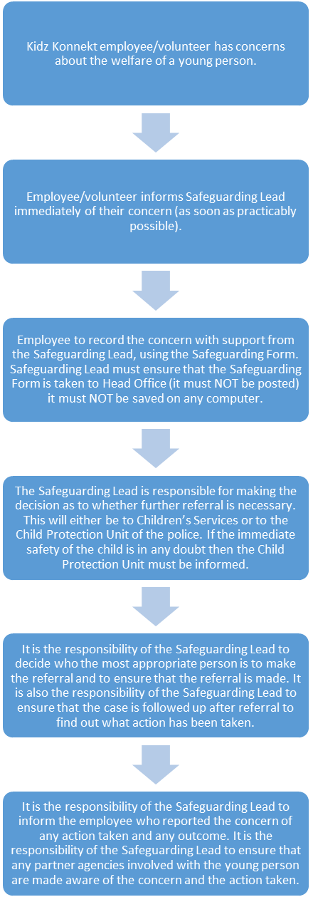

PROCEDURE FOR DEALING SUSPICIONS, WITH ALLEGATIONS AGAINST A MEMBER OF STAFF
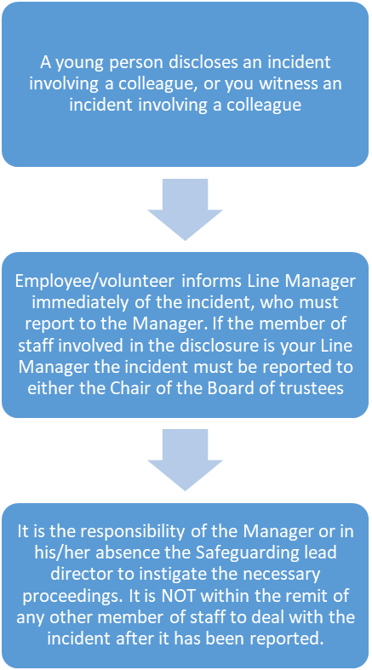

IF IN ANY DOUBT AS TO WHAT YOU SHOULD DO AT ANY TIME DURING THE ABOVE PROCEDURE SEEK ADVICE FROM YOUR LINE MANAGER OR THE SENIOR MANAGEMENT TEAM.

GUIDANCE NOTES ON DEALING WITH DISCLOSURE OR SUSPICIONS OF ABUSE OR NEGLECT
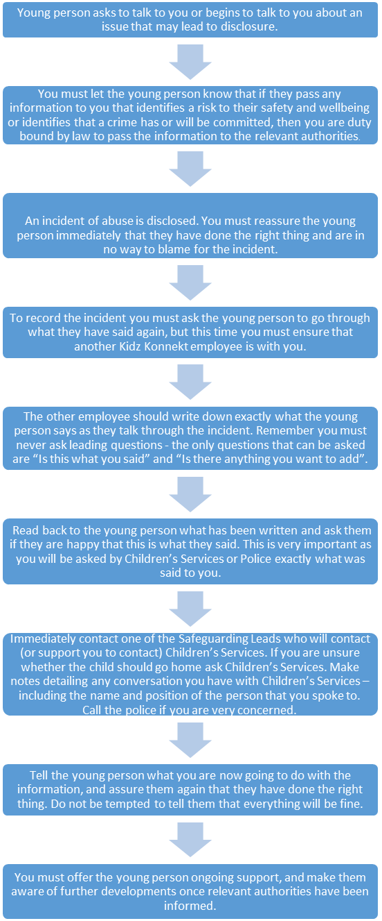
Appendix A
Senior Safeguarding Lead
Youth Development Manager
Alan Lonsdale: 07824883335

Designated Safeguarding Lead
Annie Harrison: 07538766986

Alternative Senior Lead
Joseph Whittingham: 07741637043
01642 433200

Special cases for Child Protection
a Trips away from home
Children need to be kept safe when taking trips away from home. It is therefore important that rigorous child protection policies and procedures are in place in addition to health and safety procedures, adequate insurance, etc. In putting together a trip away from home, some procedures to follow include:
General
. Ensuring children know how to behave, e.g. through a behaviour policy.
. Getting written consent from parents and, if necessary, holding a meeting for parents to give them a briefing on the outing.
. Asking parents about any special needs or requirements for their children.
Using activity centres and other external providers
. Using reputable organisations which have in place any licences or accreditation required (some adventure activities may require specific licences).
. If possible, visit the centre beforehand.
. Getting agreement on the activities to be undertaken if using an adventure activity provider.
. Ensuring external providers have proper safety procedures in place (e.g. insurance, maintenance of equipment/ transport, health and safety policies, recruitment of staff to work with children, child protection policies etc.).
. Ensuring the accommodation is suitable.
Staff/volunteers
. Having a person trained in first aid
. Have adequate staff ratios. These will depend on the age of the young people and the activity being planned, but DFES guidance on a typical school trip to a museum or historical site are:
– 1 adult to 6 pupils for under-eights (more adults if under-fives).
– 1 adult to 10–15 pupils for 8 to 11-year olds.
– 1 adult to 15-20 pupils for over-elevens.
. Ensure all those attending are aware of their roles and responsibilities.
. Ensure staff/ volunteers are competent to lead children in activities.
Even greater care should be taken over trips abroad. The Local Network Fund, for example, is reluctant to fund trips abroad because of the increased risks.
Two publications in particular provide more detailed information on planning trips away are:
- Safe Sport Away, produced jointly by the Amateur Swimming Association and the NSPCC.
- Health and Safety of Pupils on Educational Visits, published by the Department for Education and Skills, available free or to download from www.dfes.gov.uk.

b Working with children with disabilities
For a number of reasons, children with disabilities are more vulnerable to abuse than others. For example children with disabilities may be more dependent on others for intimate care and may be less able to tell people about any abuse they experience. For these reasons, it is essential that rigorous child protection procedures are in place, especially with regard to recruitment checks on volunteers and paid workers, whistle blowing policies, and having clear guidelines setting out acceptable behaviour by those working with children with disabilities.
c Groups of parents and children.
In some cases, the volunteers on a project may consist solely of parents or carers looking after their own children. It is recommended that the group still have a policy to cover the activity, as the group and its trustees are still accountable for the project. However, the policies and procedures might be adapted, e.g. to focus more on a code of conduct for parents and children whilst using the project and how parents might deal with the reporting of an allegation of abuse by a child.
d Working with older teenagers, e.g. 16+
Given that child protection legislation covers all children and young people up to the age of 18, groups working with older children are still required to have child protection policies and procedures. The policy is likely to cover the same ground as a standard policy, but the section on acceptable behaviour might reflect the age of the young people.
e Projects only involving children and young people
In reality, few projects are likely to be made up solely of young people. In most cases, adults will have some responsibilities (e.g. as management committee members), or will come into contact in some way with the children on the project. In addition, children can abuse each other (e.g., bullying). It is therefore likely that a policy for such a group would cover the same ground as a standard child protection policy.
f Capital projects e.g. where group is to provide facilities for other groups
Some projects simply aim to provide facilities for other groups or young people to use, (e.g., skate park, playground, hall). On the face of it, it may seem that a group like this does not come into contact with young people and does not need a child protection policy. In reality, this is unlikely. If a project has any involvement of volunteers, any involvement of young people, or holds meetings, consultation events or even uses a public site, a child protection policy would be extremely valuable. Any contact with young people makes it necessary to have a child protection policy, and obviously this policy can be adapted to suit the nature of your project. In addition, complete child protection may also include health and safety concerns and appropriate insurance measures, and either provision or guidelines for the use of the equipment or venue once your project has ended.
g Use of the internet
The following procedures are recommended for community groups:
. Place the computer where everyone can use it and where everyone can see it, rather than out of sight in another room.
. Supervise use of the internet.
. Suggest sites that could be visited by children and young people, (e.g., those connected with children’s TV programmes)
. Talk to children and young people about what sorts of sites they can and cannot visit.
. Inform children about chat sites are open to misuse and they should be as cautious of people they meet on the internet as adults they may meet in real life.
. Advise children and young people to not give out personal details over the internet, e.g. surname, address, phone number or e-mail address.
. Advise children to never arrange a face-to-face meeting with anyone they come into contact with on the internet.
. Encourage children to report anything they come across which they feel is abusive or offensive.
. Limit the amount of time children spend online.
. Explore the use of filters which block access to certain sites (although remember that these are unlikely to be foolproof and cannot replace proper supervision).
. In addition, groups should not publish recognizable photographs of children on their own websites

Appendix B

Child protection, the law and other references in rural Sussex
a Legal context

There are a number of recent Acts of Parliament relevant to the area of child protection. The Acts mentioned below provide the legal framework in which child protection takes place. As such, any child protection policy should explicitly refer to these Acts to show how the policy fits within this legal framework.
. The Children’s Act 1989: This Act sets out how the welfare and developmental needs of children are of paramount importance and over-ride other considerations. Two key sections of the Act are:
Section 17, which sets out the rights of children to have an assessment of their needs and the role of statutory bodies in ensuring these rights are met.
Section 47 which sets out a local authority’s responsibility to investigate if it believes that a child is suffering is likely to suffer significant harm.
. The Protection of Children Act 1999: This Act sets out the framework to enable employers to check on the suitability of employees seeking to work with children. Groups defined specifically as ‘childcare organisations’ must apply the provisions of the Act, whilst other organisations working with children are encouraged to do so. The Act builds on the Police Act (1997) which set up the Criminal Records Bureau. A childcare organisation is defined as an organisation ‘which is concerned with the provision of accommodation, social services or health care services to children or the supervision of children’.
. The Human Rights Act 1998: This Act sets out the rights of children and families and reflects principles in international agreements. The Act gives the public the right to challenge what they perceive as an infringement of their human rights.
. Sexual Offences (Amendments) Act 2000: This Act introduced the concept of abuse of trust, whereby adults could commit an offence in engaging in sexual activity with someone younger than them if they are seen to be in a position of trust, even if the younger person is above the age of consent (e.g. teachers and pupils).
. The UN Convention on the Rights of the Child: This includes a young people’s charter; setting out how all children should have access to basic human rights. The Convention on the Rights of the Child outlines in 41 articles the human rights to be respected and protected for every child under the age of 18 years and requires that these rights are implemented in the light of the Convention’s guiding principles.
As a result of the Victoria Climbié enquiry and the Laming Report (2003), the government is reviewing the law regarding child protection, and the responsibilities of all agencies that care for Children and Young People. You should always make sure that you have the most up-to-date policies on which to base your work and procedures. You can find up-to-date information from the NSPCC (http://www.nspcc.org.uk/) or your local Area Child Protection Committee (http://www.acpc.gov.uk/).
b Government Publications
In addition to the laws in this area, government departments have produced a number of publications which give guidance on how the provisions or principles of the Acts are to be put in place. The main publications are as follows:
. Working Together to Safeguard Children (1999): This sets out the way in which all organisations working with children should seek to work together and have clear procedures on child protection, in line with the local Area Child Protection Committee (ACPC) procedures. (Home Office, Department of Health, Department of Education and Employment) http://www.doh.gov.uk/quality5.htm
. Safe from Harm (1993): This is a code of practice for safeguarding the welfare of children that is aimed at voluntary organisations. It sets out procedures which voluntary groups should consider adopting to safeguard children. Available from
Home Office, Publication enquiries, 50 Queen Anne’s Gate, London SW1H 9AT; www.homeoffice.gov.uk/acu/harm.htm)
. Caring for the young and vulnerable (2000): This is Home Office guidance on the need to ensure appropriate boundaries between volunteers or paid workers and young people. If these boundaries are broken, the volunteer or paid worker would be
subject to prosecution and having the details recorded by the Criminal Records Bureau. Can be downloaded from the Home Office: http://www.homeoffice.gov.uk/cpd/sou/young.htm
c Additional Resources
. Educare Home Study Programme (NSPCC). For further information, telephone the NSPCC National Training Centre on 0116 234 0804 or http://www.nspcc.org.uk/inform/CH_Training.asp
£26.44 inc VAT
. First check: a step by step guide for organisations to safeguard children (NSPCC) Available from NSPCC,
Tel: 0116 234 0804 or
http://www.nspcc.org.uk/inform/CH_Training.asp.
£21.50
. Health and Safety of Pupils on Educational Visits (DFES). Available from the Department of Education and Skills, http://www.dfes.gov.uk/h_s_ev/. The guide is free and can be ordered from DfES publications on Tel: 0845 6022260 or email dfes@prolog.uk.com. Quote Ref HSPV2
. Health and Safety in Youth and Community Work: A pocket guide (Doug Nicholls), Health and Safety in Youth and Community Work: A resource manual (Doug Nicholls) Both available from Russell House Publishing Ltd, 4 St Georges House, Uplyme Road Business Park, Lyme Regis, DT7 3LS)
. Safeguarding Children – Everybody’s Business – video training pack (NSPCC) Available from NSPCC ,
Tel: 020 7825 2775. £80.25
. Safe Sport Away (Amateur Swimming Association & NSPCC). Available from NSPCC Child Protection in Sport Unit, Tel: 0116 234 7278.
. Working with Young People: Legal Responsibility & Liability, 5th Edition. Available from: The Children and Young People’s Legal Centre, University of Essex, Wivenhoe Park, Colchester, Essex, CO4 3SQ
Tel: 01206 872466
Action in rural Sussex

Appendix C

Ways to recognize Child abuse and neglect
a Physical Abuse
Visible Signs:
. Injuries to any part of the body
. Children who find it painful to walk, sit down, to move their jaws or are in some other kind of pain
. Injuries which are not typical of the bumps and scrapes associated with children’s activities
. The regular occurrence of unexplained injuries
. The child who is frequently injured, where even apparently reasonable explanations are given

Behavioural Signs:
. Furtive, secretive behaviour
. Uncharacteristic aggression or withdrawn behaviour
. Compulsive eating or sudden loss of appetite
. The child who suddenly becomes ill co-ordinated
. The child who finds it difficult to stay awake
. The child who is repeatedly absent

What to listen for:
. Listen for confused or conflicting explanations of how the injuries were sustained
. Evaluate carefully what is said and preferably document it verbatim
. Consider if the explanation is in keeping with the nature, age and site of injury

Consider:
. What do you know about the family?
. Is there a history of known or suspected abuse?
. Has the family been under stress recently?
. Do you have concerns about the family?

b Emotional Abuse
The recognition of emotional abuse is based on observations over time of the quality of relationships between parent/carer and the child

Watch for parent/carer behaviours
. Poor attachment relationship with the child
. Unresponsive or neglectful behaviour towards child’s emotional or psychological needs
. Persistent negative comments about the child
. Inappropriate or inconsistent developmental expectations of the child
. Parental problems that supersede the needs of the child
. Dysfunctional family relationships including domestic violence

Watch for child behaviours:
. Emotional indicators such as low self esteem, unhappiness, fear, distress, anxiety
. Behavioural indicators such as attention seeking, opposing, withdrawn, insecure
. Physical indicators such as failure to thrive/faltering growth, delay in achieving developmental, cognitive or educational milestones
Appendix
c Sexual Abuse
There may be no recognisable signs of sexual abuse but the following indicators may be signs that a child is or has been sexually abused:

Physical signs
. Signs of blood or other discharge on the child’s under clothes
. Awkwardness in walking or sitting down
. Tummy pains
. Regression into enuresis
. Tiredness

Behavioural signs:
. Extreme variations in behaviour (e.g., anxiety, aggression, or withdrawal
. Sexually provocative behaviour or knowledge that is incompatible with the child’s age and understanding
. Drawings and/or written work which are sexually explicit (indirect disclosure)
. Direct disclosure; It is important to recognise that children have neither the experience no the understanding to be able to make up stories about sexual assault.

d Neglect

Indicators of neglect are recognisable in the child, in the parent/carers’ behaviour and within the home environment.

Physical signs
. Abnormal growth including failure to thrive
. Underweight or obesity
. Recurrent infection
. Unkempt dirty appearance
. Smelly
. Inadequate/unwashed clothes
. Hunger
. Listlessness

Behavioural signs:
. Attachment disorders
. Indiscriminate friendliness
. Poor social relationships
. Poor concentration
. Developmental delays
. Low self esteem
Environmental signs:

. Insufficient food, heating and ventilation in the home
. Risk from animals in the household
. Inappropriate sleeping arrangements and inadequate bedding
. Dangerous or hazardous environment

This Policy was adopted in 2018
Policy Review / update

2019: Reviewed Alan Lonsdale Jan 6th
2020: Reviewed Alan Lonsdale March 30th
2021: Reviewed Alan Lonsdale April 2nd
2022: Reviewed Alan Lonsdale May 5th
2023: Reviewed Alan Lonsdale April 17th
2024:
2025:

